**B. P. Poddar Institute of Management and Technology**

**Department of Computer Science & Engineering**

**Software Engineering Lab (ESC-591)**

**AY: 2024-25 ODD Semester**

**Assignment-4 (Data Flow Diagrams)**

**Group No. (Case Study No.) _______1_______**

**Case Study Title: ____Mental Health Care – Patient Management System**_______

**Student Details:**

|  |  |  |
| --- | --- | --- |
| **Univ. Roll. No.** | **Name** | **Contributions in DFD**  **(Level/process)** |
| **11500122034** | **Srijeeta Dutta** | **Made the Data**  **Dictionary** |
| **11500122036** | **Sajal Kumar Ghosh** | **Wrote Case Study**  **Description** |
| **11500122057** | **Ajay Raj** | **Drew the DFD Diagram** |
| **11500122061** | **Ritesh Mahanti** | **Wrote what is DFD and use in SDLC** |
|  |  |  |

Everybody has contribution in drawing DFD level 0 and level 1 diagram.

Signature of Faculty with date________________________________________________

**Case Study Description:**

* A patient information system to support mental health care is a medical information system that maintains information about patients suffering from mental health problems and the treatments that they have received.
* Most mental health patients do not require dedicated hospital treatment but need to attend specialist clinics regularly where they can meet a doctor who has detailed knowledge of their problems.
* To make it easier for patients to attend, these clinics are not just run in hospitals. They may also be held in local medical practices or community centres.
* The MHC-PMS (Mental Health Care-Patient Management System) is an information system that is intended for use in clinics.
* It makes use of a centralized database of patient information but has also been designed to run on a PC, so that it may be accessed and used from sites that do not have secure network connectivity.
* When the local systems have secure network access, they use patient information in the database but they can download and use local copies of patient records when they are disconnected.

**Functional Design using Data Flow Diagrams**

*Write briefly what are DFDs and their usage in design phase of SDLC*

Data Flow Diagrams (DFDs) are visual representations used to illustrate how data moves through a system, including its sources, processes, storage, and destinations. In the design phase of the Systems Development Life Cycle (SDLC), DFDs play a vital role by providing a clear, structured overview of the system's data interactions. They help in clarifying system requirements, documenting data handling processes, and communicating design concepts to both technical and non-technical stakeholders. Additionally, DFDs assist in identifying potential issues such as inefficiencies or redundancies in data flow, thereby guiding the development of a more effective and streamlined system.

**https://online.visual-** **paradigm.com/app/diagrams/#diagram:proj=0&type=UseCaseDiagram&width=11&heig**

**ht=8.5&unit=inch**

**Context Level/DFD Level 0:**

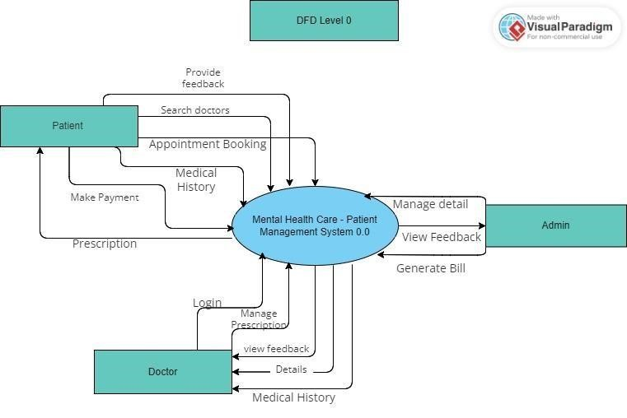

*--------------------------------------------------------------------------------------------------------------------------------*

**DFD Level 1:**

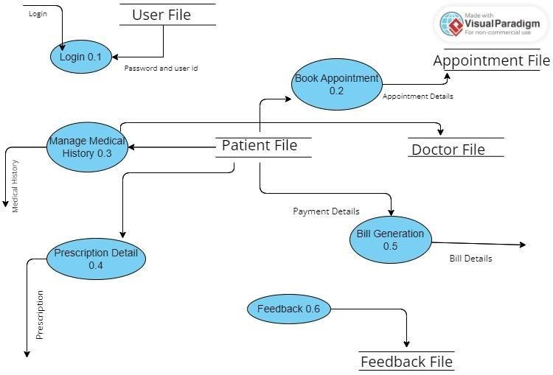

**0**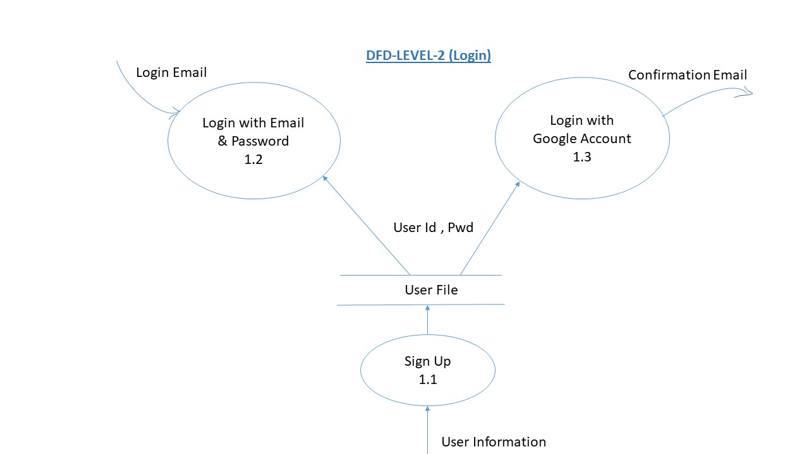

**Data Dictionary:**

* Patient_ID() = Alphanumeric(10) - Unique identifier for each patient.
* Patient_Name() = FirstName + " " + LastName - Full name of the patient.
* Gender()= Enum(Male | Female) - Gender of the patient.
* Date_Of_Birth() = Date of birth of the patient. (YYYY-MM-DD) • Contact_Number() = Numeric(10) - Contact number of the patient.
* Email() = Alphanumeric(30) - Email address of the patient.
* Address() = Alphanumeric(150) - name + #house + #street +#city+#pin - Address of the patient.
* Medical_History() =Summary of the patient's medical history and conditions.
* Next_Appointment()= DateTime(YYYY-MM-DD HH:MM) - Date and time of the patient's next scheduled appointment.
* Mental_HealthStatus() = Enum(Stable | Improving | Declining) - Assessment of the patient's current mental health status.
* Appointment_DateTime() = AppointmentDate + " " + AppointmentTime (YYYY-MM-DD HH:MM AM/PM) - Date and time of the scheduled appointment.
* Appointment_Type() = Alphabetic(50) - Type of appointment (e.g., Initial Assessment, Follow-up, Therapy Session).
* Bill() = DiagnosisFee + {MedicineItemPrice + Quantity}*-– Total Bill including other details
* Billing_Records() = Record of billing and payment information related to the patient.